Will we all be renting clothes in the future?

We rent cars, houses and even movies all the time, so why not rent our clothes too? Renting your clothes is cheaper, easier and even eco-friendly. Places like *Rent the Runway* and *LeTote* are gaining more and more subscribers everyday. For those of you who do not know that renting clothes is the new thing, check again.



Renting clothes is not as big ~*right now~* as it should be, and it has its number of haters, but it might be the basis of our closet’s future. Just like subscription boxes, many of these companies run on memberships. Pay a certain amount per month, wear the clothes for however long you’d like, then return all together when you’re over the pieces. Most of the hate comes from those who do not want to return the items they get, but little do they know, you can buy them if you decide to. As more companies decide to rent out their clothes rather than just sell them, they are creating a floor for new target markets and a bigger consumer base.

Clothing rental companies are popping up all over the globe, and the biggest concern for consumers is wearing clothes that have been worn before. Are they dirty? Do they get washed? Will they be top quality or just rip the minute I try it on? Trust me, I had the same concerns. *YCloset,* a Chinese startup for renting out clothing, answered all these questions with their latest advertisement campaign. The marketing video went viral by taking viewers on a tour throughout their laundry institutions. Showing massive washing machines, tons of steam presses, and workers who make sure every article of clothing is in top shape between customers. As the behavior of renting clothes grows, companies are trying their best to show customers that this is an eco-friendly and clean operation. Now that campaigns like *YCloset*’s advertisement are coming about, consumers are enjoying the ease that comes with renting clothes, and feeling good about it too.

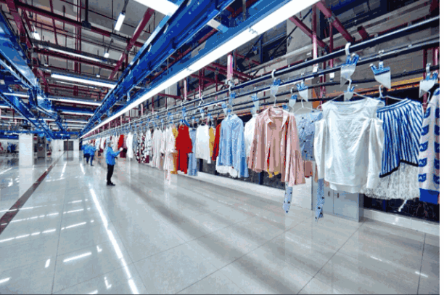

As human beings, we naturally have the desire to want new things. We are materialistic and sometimes greedy; it's normal. But getting new things does not mean we need items fresh off the factory line and throw it out when our styles change. If we detach the idea that all new things need to be *new*, our wardrobes can get larger without putting a dent in our wallets, and the environment will thank us for it as well. Remember that bright red dress you wore to your cousin's wedding last year? If you would have rented that dress, would anybody have any idea? Probably not because the dress is new to *you.* The newness of clothes does not directly relate to how long it’s been since being stitched together. Data shows, Americans throw away about 12.8 million tons of textile annually. This calculates to about 80 pounds of clothing for each man, woman and child a year. Our “fads” are filling our landfills, and we don't even realize it. Industries are trying to fix this with their recycling programs and re-sell programs.

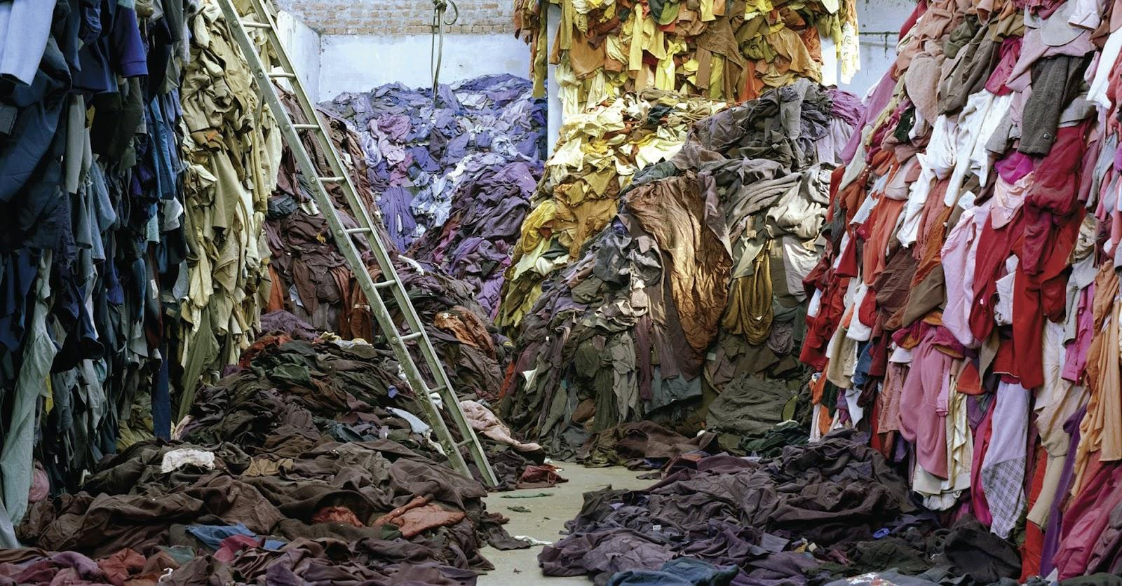

Rental companies are using this environmental aspect to their advantage by showing consumers that this is a clean, green way to update your closet. Upcoming generations are caring more and more about the environment while getting involved with convenient practices, like renting clothes, to do their part. Renting your wardrobe is the newest thing to do and if you don’t join in fast, you might miss out!

Links:

<https://www.groupon.com/deals/rent-the-runway>

<https://cpb-eu-w2.wpmucdn.com/blogs.brighton.ac.uk/dist/b/1668/files/2018/11/Screenshot-2018-11-23-at-13.35.28-1sajacd.png>

https://remake.world/stories/news/are-our-clothes-doomed-for-the-landfill/